PRODUCT INVENTORY MANAGEMENT SYSTEM

Team ID : SWTID-2026-9497
Project Team Leader:
- Loghitha S (loghithasaravannan@gmail.com)
Project team members:
- A. Logeshwari (logi95077@gmail.com)
- K. Rogini (roginikupusami@gmail.com)
- B. Sakthi Sri (sakthisri9906@gmail.com)
- P. Dharani (ddharanidharani38@gmail.com)
Technology: Node.js
Testing Tool: Thunder Client

Introduction
Product Inventory Management System is used to manage and track product information in an organized way. This system helps users to store, update, retrieve and delete product details easily. The system is developed using Node.js for backend development. The APIs are tested using Thunder Client inside Visual Studio Code. This project helps in maintaining product records efficiently in a digital format.

Objectives of the Project
The main objectives of this project are:
- To manage product details efficiently.
- To store product information in a structured format.
- To perform CRUD operations (Create, Read, Update, Delete).
- To allow users to register and login securely.
- To provide an easy system to manage inventory products.

Technologies Used
The technologies used in this project are:
- Node.js – Used for backend development.
- JavaScript – Programming language used to write the logic.
- Visual Studio Code – Code editor used to write and manage the project.
- Thunder Client – Used to test API requests and responses.
- Node Modules – Installed packages required for the project.

Project Structure
The project contains the following folders and files:
node_modules – Contains installed packages required for the project.
src – Contains the main source code of the application.
package.json – Contains project information and dependencies.
server.js – Main file used to start the server.

User Authentication
The system provides user authentication features to ensure security.
Register:
New users can create an account by providing their details.
Login:
Registered users can log in to access the product management system.
Authentication helps to protect the system from unauthorized access.

Product Management
The system allows users to manage product information with the following operations.
Add Product:
Users can add a new product with details such as product name, price and quantity.
Get Product:
Users can view the list of all products stored in the system.
Update Product:
Users can modify the details of an existing product.
Delete Product:
Users can remove a product from the inventory system.

API Endpoints
The following API endpoints are used in the system:
POST /register – Used to register a new user.
POST /login – Used for user login.
POST /product – Used to add a new product.
GET /product – Used to retrieve product details.
PUT /product/:id – Used to update product information.
DELETE /product/:id – Used to delete a product.
These APIs are tested using Thunder Client.

Testing
The APIs of this project are tested using Thunder Client in Visual Studio Code. Each API request such as register, login, add product, get product, update product and delete product was tested successfully to ensure that the system works correctly.

Advantages
- Easy to manage product information.
- Saves time compared to manual inventory management.
- Provides accurate product tracking.
- Simple and efficient system.

Conclusion
The Product Inventory Management System helps in managing product details efficiently. The system allows users to register, login and perform CRUD operations on product data. Using Node.js and API testing tools, the project demonstrates how inventory management can be handled effectively in a digital system.
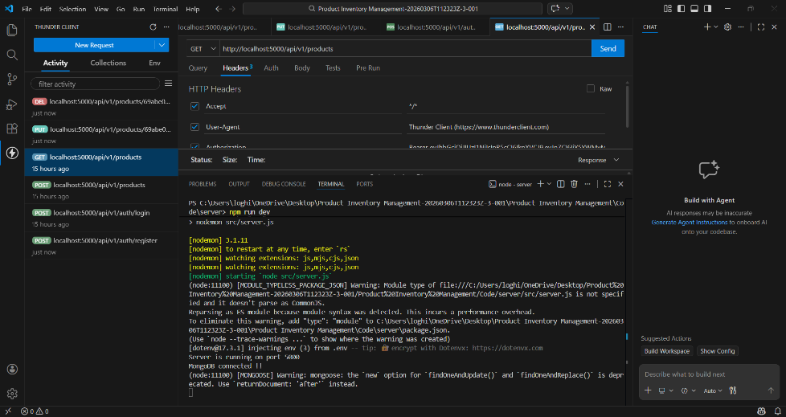
Thus the Product Inventory Management was successfully executed .Project demo video link : https://drive.google.com/file/d/1VUJ71Ck0qGxFORytHlagDJDEBV_qHC1G/view?usp=sharing

